Name: Quang Huynh Date __________

Algebra 2 Trig Practice Quiz

Determine the quadrant in which the angle terminates.

- = 162 Quadrant 2 3. = 400 Quadrant 1

2. = -200 Quadrant 2 4. = 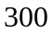 Quadrant 4

_____1____5. The terminal ray of an angle drawn in standard position passes through the point 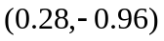 which lies on the unit circle. Which of the following represents the cosine of this angle?

- 0.28 (3) 0.96
- -0.28 (4) -0.96

_____1____6 . Which of the following is not equal to the 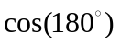?

(1) 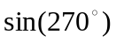 (3) 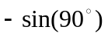
(2) 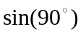 (4) 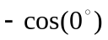

____2_____7. If 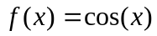 and 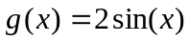, what is the exact value of 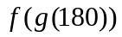?

- 1 (3) -1
- 0 (4) 

_____1____8. Written in exact value form, 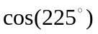=

(1) 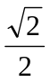 (3) 
(2) 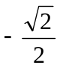 (4) 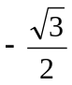

___3______9. Which of the following is not in the range of 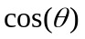?

- (3) 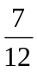
- (4) 

____4_____10. Which of the following is a coterminal angle with 120?

(1) -120 (3) 60
(2) 30 (4) -240

_____2____11. If , what is the exact value of ?

(1) (3)
(2)  (4)

____3_____12. Which of the following is the reference angle to 120?

- -120 (3) 60
- 30 (4) -240

____4_____13. Which of the following is false?

(1) 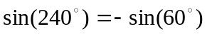 (3) 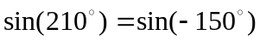
(2) 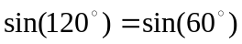 (4) 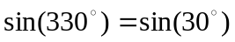

_____2____14. If 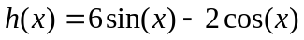, what is the exact value of 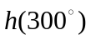?

(1) 1 (3) 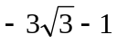
(2) 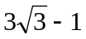 (4) 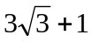

____1_____15. If Sin(x) < 0 and Cos(x) < 0, then the angle x must be located in Quadrant…

(1) I (3) III
(2) II (4) IV

